Chapter 3, Problem 61.

Calculate the current gain i_{o}/i_{s} in the circuit of Fig. 3.105.

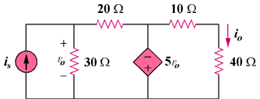

Figure 3.105
For Prob. 3.61.

